Final

Contents

Executive Summary 2

Requirement Definitions 3

Use Cases 4

Use Case Diagram 8

Additional Information 9

# Executive Summary



# Requirement Definitions



# Use Cases



# Use Case Diagram



# Data Flow Diagrams

**Level 0 DFD**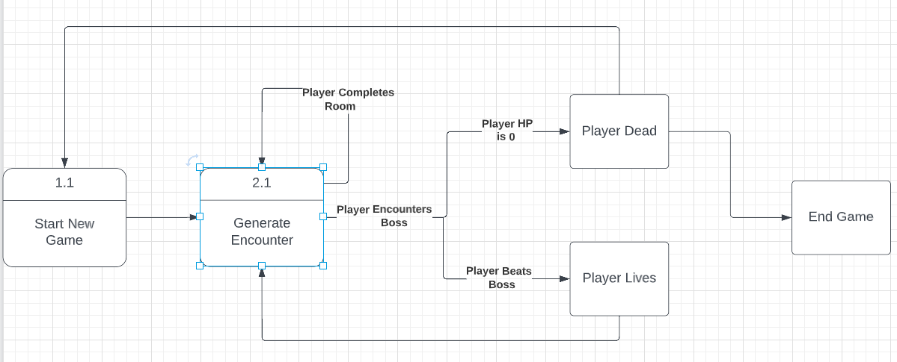

**DFD UC-2**

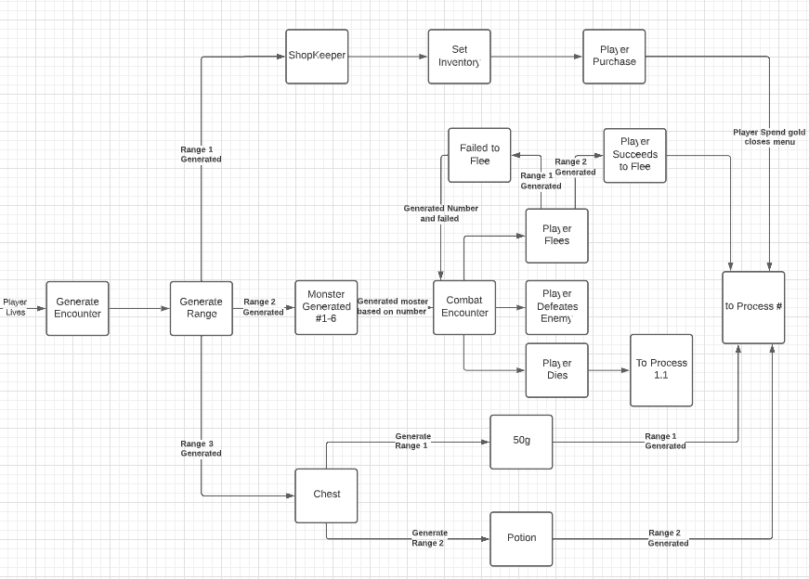

# Additional Information

RB Whitaker- The C-Sharp Player Guide-Starbound Software (2022)

* + what have you accomplished in planning your project thus far?
  + I added code to the combat menu, magic menu, generated encounters, hp, mp, shop
* what challenges have you faced?
  + Coming up with different use cases, Requirements writing them in past tense and a more professional context
* Looking forward in short to the next steps of the project, what do you anticipate being your next step?
  + I anticipate to do some coding to flesh out the project.